**Activity Progress Report:**

* **PM documents closed (badis) risk management (added delay, lack of competence) (add more human hours, outsource) added references, and annex.**
* **Conops (haakon): make a new system overview, re-did the survey with only employees’ data to confirm the users requirements (as they are the main users)**
* 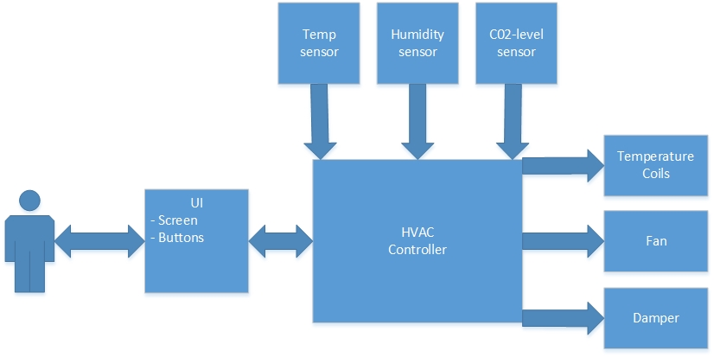**Survey analysis (arshard) improve it accordingly to Aurilla’s comments.**
* **Made some ideas of improvements (what could be done different)**
* Should have investigated every aspect of problems before making any decisions, Voice control..
* The mistake of stating solution early stage of the process.
* Putting the solutions choice in the survey has influenced the final decision
* Should have specified the stakeholders before creating the survey
* **Choose system design concept** (pugh, AHP matrix) Panel control.
* **Systems requirements. Researched a bit how different parameters would be controlled.**

|  |  |  |
| --- | --- | --- |
|  | Stakeholder requirement | System requirement |
| User | User would like to customize indoor environment by regulating temperature, humidity and air quality | Have an accessible interface for regulating temperature, humidity and air quality. |
| Facility manager | Long operational life | Should have a cabled connection to electricity |
| Easy maintenance and monitoring | Possibility to monitor the status of multiple panels. |
| HVAC vendor | Easy deployment of control system |  |
| Compatible with their equipment | Protocol of communication must be compatible. |
| Government | Meet regulations |  |

* Collect data from sensors
* Regulate parameters, description?!

1. Regulate temp between this range (15° to 30°) by controlling the heating/cooling coils and radiators.
2. Regulate humidity between 25 and 60%. Usually air is humidified to between 25 -45% during winter and dehumidified to below 60% during summer. Any figure outside this range shall produce discomfort and indoor air quality (IAQ) problems. by controlling the evaporating coils.
3. Regulate air quality depending on co2 by entering more fresh air by controlling the fans/dampers.

* Send updates on current situation of indoor environment
* Send updates on the state of the panel
* Display the value of each parameter
* Have user input through buttons
* **Functional analysis (Charlie made the drawing) and a description of it (badis)**
* After system requirements were specified, functional analysis of the system is made. The figure below depicts from the requirement on top to the different functions that the control panel should carry out, to the components required to yield the needed functions. Since the main stakeholders considered are the employees and they want the access to regulate their indoor environment (temperature, humidity, air quality), and to realise that some functions are needed, as to input users’ settings, collect the indoor environment data, display current values, calculate, change. The components involved in the system are sensors, actuators, network, panel (including controller, buttons, screen).

